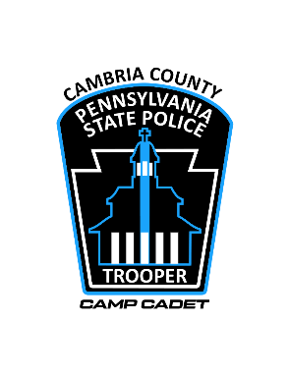

GOLF SCRAMBLE CAMBRIA COUNTY CAMP CADET, FRIDAY, JUNE 28th, 2024
EBENSBURG COUNTRY CLUB __________________________________
Golfer Registration
- $580.00 per foursome Pre-payment is only way to guarantee a spot.
- Registration fees includes: Golf, soft drinks, 4 beer tickets, lunch during registration, meal after golf, 50/50 entry, awards for placing teams, entry in skill competitions, long putt competition, golfer gift, door prize drawings during meal.
- Additional raffle for a shotgun and Blackstone griddle ($2.00/chance).
- Registration begins at 10:30 and concludes at 11:30 a.m.
- Complimentary beverages will be provided. Meal and awards follow.
- Opening comments followed by a 12:00 p.m. shotgun start.
- Register online at cambriacountycampcadet.org click on the GOLF TOURNAMENT link at top of webpage.
- Payments can be made by mail or in-person the day of the event.

Deadline for golfer registration: Friday, June 14, 2024

My foursome will include the following:

Team Captain: __________________________________________

Address: _______________________________________

Phone: _______-______-_______ City/State/Zip: _________________________________

Email Address: _________________________________

Golfer #2 / Phone: ___________________________________________________________

Golfer #3 / Phone: ___________________________________________________________

Golfer #4 / Phone: ___________________________________________________________

I will forward my names at a later date.
[Grab your reader’s attention with a great quote from the document or use this space to emphasize a key point. To place this text box anywhere on the page, just drag it.]

Please send registration and payment forms to: Camp Cadet of Cambria County. 2770 New Germany Road, Ebensburg, PA 15931 (Attn: Don Neisner). If you have questions, email Cambriacountycampcadetgolf@gmail.com or call Don Neisner at (814) 243-0520.

