Cadet,

The following is a list of items to bring, and also items NOT to bring with you to Camp Cadet. Please insure you have the following items with you when you arrive at Camp:

|  |  |
| --- | --- |
| **ITEMS TO BRING TO CAMP:** | **ITEMS NOT TO BRING TO CAMP:** |
| Soap and Shampoo | Cell Phones |
| Toothpaste and Toothbrush | iPods |
| Brush or comb | Radios / TV |
| Deodorant | Watches / Jewelry of any kind |
| **3** - bath towels and **3** - wash cloths | Camera |
| **7** **to 14** pairs of underwear – enough for daily change | Electronic/Hand Held Games |
| **7 to 14** pairs of ankle high white socks | Money |
| **4** - pairs of black, mid-thigh, mesh style shorts. (no stripes or markings, no holes - elastic waist band, draw string style) | Tobacco products of any kind |
| **7** - Plain White, crew-neck style, T-shirts | Guns / BB guns / Water Pistols / Knives |
| **2** - Pairs athletic style shoes. | Pets |
| **1** - Safety razor for females | Food, including candy or gum |
| Hairbands for females with long enough hair to pull up in a ponytail | Hair dryer / curling irons |
| FEMALES – White Sports Bras. No Colors or Designs, as they show through the white  t-shirts |  |
| Mesh Laundry Bag for soiled linens.  NO GARBAGE BAGS | Make-up / cologne / perfume |
| **1**- pillow | Lighters / Matches |
| Pajamas | Books / Magazines / Playing Cards |
| **1**- Plain Gray Sweatshirt and  **1**- Pair of Plain Gray Sweatpants.  No markings or logos. | Any extra items will be sent home. Any illegal items will be confiscated and will result in prosecution. |
| **1** - Pair of shower shoes, can be flip flops | All personal items will be inspected at check-in. We reserve the right to take any items, which we deem to be dangerous and hold same until the end of camp. Any cadet who fails to follow the rules and regulations of the camp will be expelled. |
| **1** - Over the shoulder book bag / Back Pack Style |
| Any medications that will be required during the week should be placed in a zip lock baggie and each medication marked with the cadet’s name on it. |
| **1** - Fitted Mouth Guard for Boxing | **MALES – MUST BE CLEAN SHAVEN** |
| SUN SCREEN |  |
|  |  |
| **Camp Cadet Will Provide Bed Linens – You Must Bring a Pillow** | |

PLEASE NOTE – Under Socks and Underwear, you must bring at least 7 pairs, but we encourage you to bring more (up to 14 pairs) in the event your feet get wet etc.

See back of this page for additional information

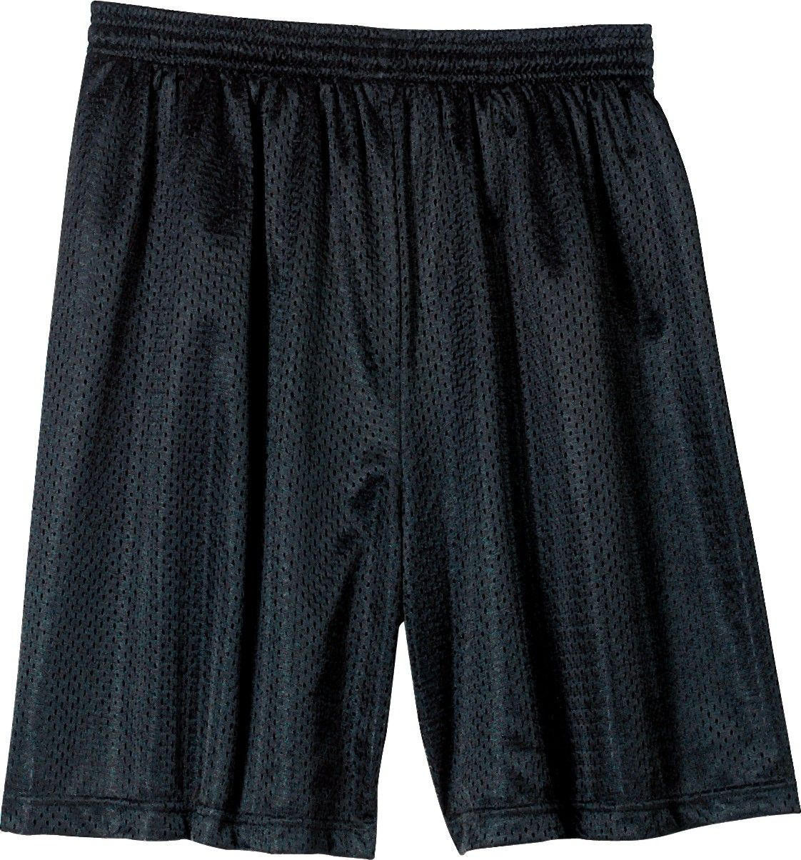

SHORTS – Mesh Style



MOUTH GUARD

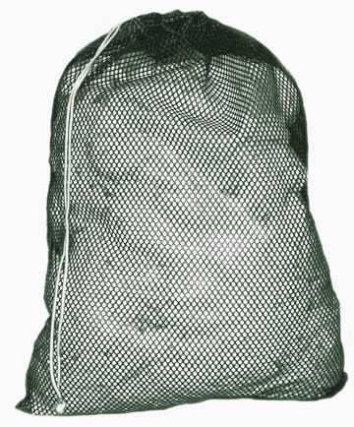

Laundry Bag

[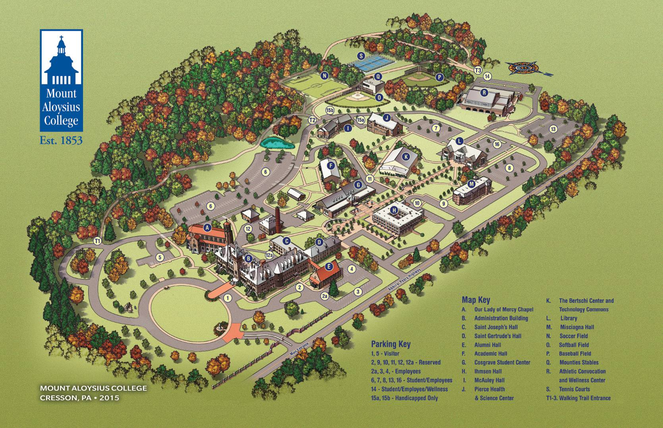](https://www.google.com/url?sa=i&rct=j&q=&esrc=s&source=images&cd=&cad=rja&uact=8&ved=2ahUKEwjg-srIrKbaAhXM34MKHcN6Ap8QjRx6BAgAEAU&url=https://www.mtaloy.edu/map/&psig=AOvVaw0jIySad12AzhgVZkJcyOuE&ust=1523128123581561)

**Graduation  
Saturday**

**8/4/18 @ 11 AM**

Main Entrance to

Mount Aloysius College

**Drop Off**

**On Sunday,**

**7/29/18 @ 1 PM**

REMEMBER

Be in Parking Lot #6 on Sunday, July 29, 2018

by 1 PM for check in.

Graduation is Saturday, August 4, 2018 at 11 AM